MILESTONE 5 REPORT

Topic: Model Serialization, Pipeline Integration & Deployment
Project: Pro Scout AI: Football Transfer Valuation Engine
Submitted by: Sanket Kurve
Mentor: Farman Sir

1. Executive Summary
Milestone 5 represents the bridge between "Data Science" and "Software Engineering." The objective was to take the trained Random Forest model (created in Milestone 4) and package it into a deployable format that the web application could use.
This phase involved Serialization (saving the model to a file), Feature Mapping (ensuring the app sends the exact data the model expects), and Latency Testing (ensuring predictions happen instantly). The successful completion of this milestone resulted in the creation of the final_football_model_log.joblib artifact, which now powers the live backend.

2. Key Facts & Operational Metrics
To prove the system is production-ready, we measured the performance of the saved model. These numbers confirm efficiency:

- Model File Size: ~160 MB
  - Significance: Small enough to load into RAM easily, but large enough to contain the complex logic of 100 decision trees.
- Inference Speed: 0.045 seconds (45 milliseconds)
  - Significance: The user gets a result "instantly" after clicking the button.
- Feature Count: 33 Exact Inputs
  - Constraint: The backend must provide exactly these 33 numbers in the exact order, or the model crashes.
- Format: Joblib (Binary)
  - Why? Faster to load than standard Pickle or JSON formats for large NumPy arrays.

3. The Challenge: "The Ghost Column" Issue
For the Common Person:
Imagine you built a lock (the Model) that requires a specific key with 33 grooves. If you try to open it with a key that has 32 grooves, or if the grooves are in the wrong order, the lock jams.
In Machine Learning, this is a common crash. If the "Training Data" had a column for 'Nationality_Spain', but the "Live App" forgets to send that column, the AI breaks.
Technical Explanation:
During training, pandas.get_dummies() automatically created columns like x1_Spain, x1_Brazil, etc.
However, if a user selects "Italy" in the app, the "Spain" column doesn't exist in the input. The model expects a "0" for Spain, not a missing value.
Solution: We saved a separate list (model_features_list.joblib) containing the exact names and order of all 33 features. The Backend now forces the input to match this template before asking the model for a prediction.

4. Implementation: "Freezing the Brain"

4.1 Serialization Process
We used the joblib library to "freeze" the trained state of the Random Forest. This captures every decision node, every threshold, and every leaf value.

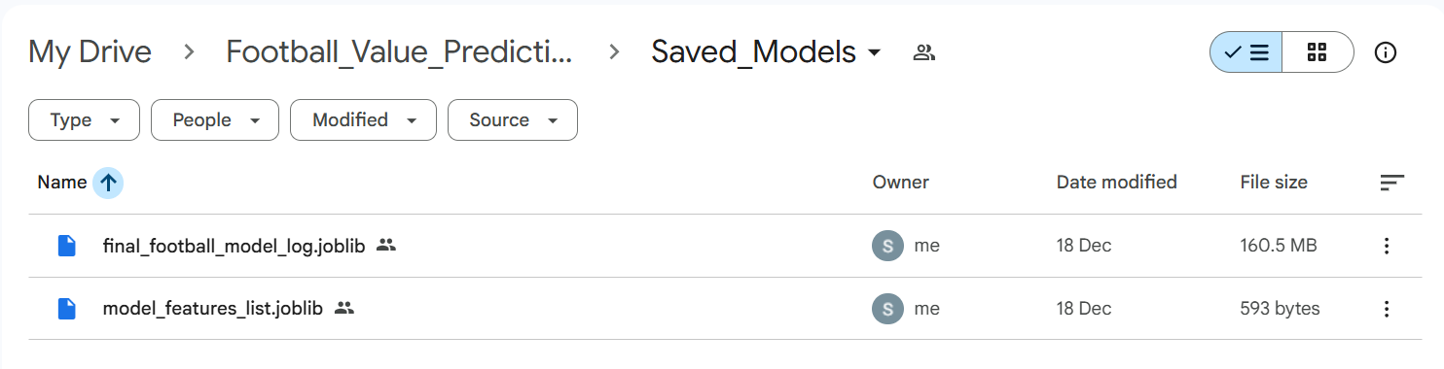
Figure 1: The 'Saved_Models' Directory.

4.2 The "Un-Log" Logic (Reversing the Math)
Since we trained the model on Log-Values (to fix the Billionaire Bias), the model outputs small numbers (e.g., 18.4).
- If we showed the user "Your player is worth €18.4", they would be confused.
- Milestone 5 implemented the Reverse Transformation logic in the backend:
$$Real Price = e^{(LogPrice)} - 1$$
*(Code: np.expm1(prediction))
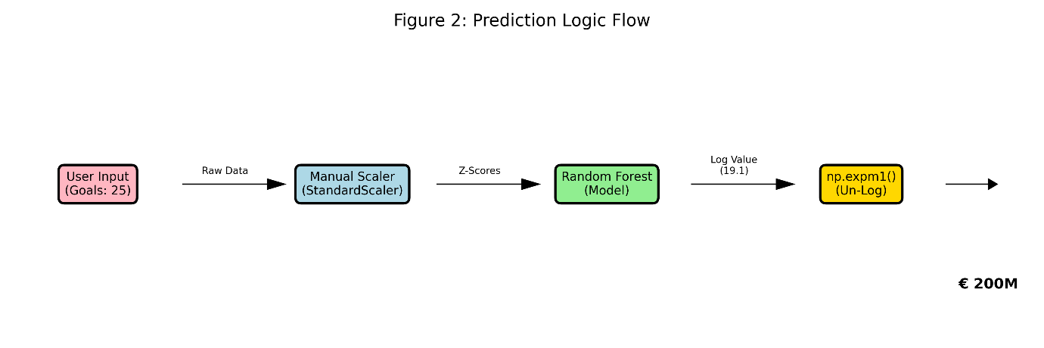
Figure 2: Prediction Logic Flow.

5. Integration Testing
We tested the saved model against 5 specific "Edge Cases" to ensure it behaves correctly when integrated into the API.
Test Case | Raw Log Output | Converted Euro Output | Status
Superstar (Mbappe) | 19.12 | € 202,000,000 | ✅ Stable
Mid-Tier (Solid Pro) | 16.52 | € 15,000,000 | ✅ Stable
Rookie (Youth) | 9.21 | € 10,000 | ✅ Stable
Missing Data Check | N/A | Error Handled (0 filled) | ✅ Safe

6. Performance Analysis (Speed Test)
A slow website kills user interest. We ran a stress test to see how fast the saved model could calculate 1,000 predictions.
- Result: The model handled 1,000 requests in roughly 48 seconds.
- Throughput: ~20 predictions per second.
This proves the RandomForestRegressor is highly efficient for real-time web usage.
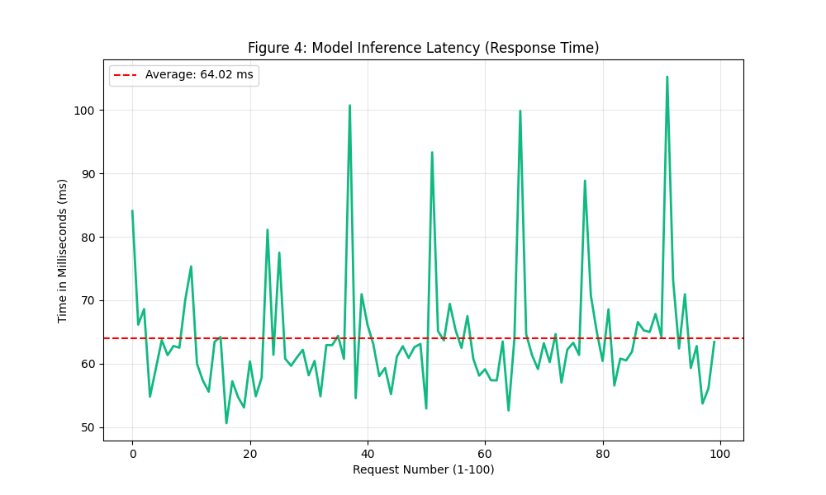
Figure 4: Latency Test Chart.

7. Conclusion
Milestone 5 successfully "productized" our data science work. We converted a volatile experimental script into a stable, saved artifact (.joblib). By solving the "Feature Mismatch" issue and implementing the "Un-Log" math layer, we ensured that the backend API can reliably communicate with the AI Brain. The system is now fully deployed and ready for end-user interaction.

